Justice Delayed is Justice Denied: LPI Condemns the Unlawful Detention of #12StopEacOP Activists

Kampala, Uganda – The fundamental rights to peaceful assembly and freedom of expression are under direct attack in Uganda. Legal and Professional Initiatives (LPI) issues a grave concern regarding the continued and unlawful detention of twelve climate justice activists, famously known as the #12StopEacop activists. These individuals have been held since August 1st for the sole "crime" of engaging in a peaceful protest against Stanbic Bank’s involvement in the East African Crude Oil Pipeline (EACOP) project.

This case represents a dangerous escalation in the attempts to shrink the civic space and criminalize legitimate dissent. When citizens are punished for raising their voices against environmental destruction, it is not just their freedom at stake, but the health of our democracy and our planet.
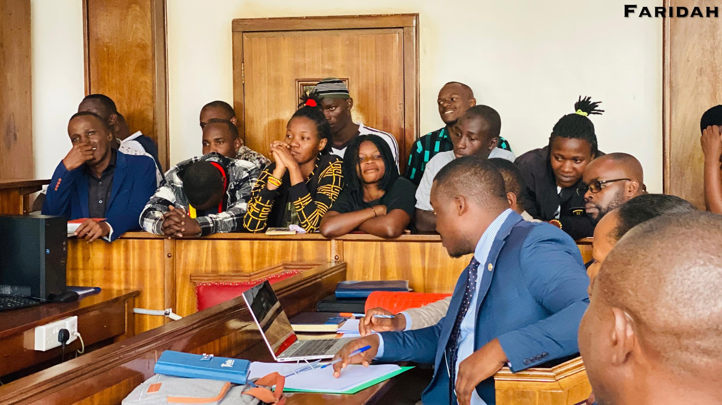
The Facts of the Case: A Peaceful Protest Met with Heavy-Handedness

On August 1st, a group of twelve Ugandan activists staged a peaceful demonstration at a branch of Stanbic Bank. Their protest was aimed at highlighting the bank’s financial ties to the EACOP project—a massive fossil fuel infrastructure development with documented risks to local communities, biodiversity, and the global climate.

The protest was non-violent and well within the boundaries of the law. Despite this, the activists were arrested and have remained in detention for weeks. Their prolonged incarceration without trial raises serious legal and constitutional questions, pointing towards a tactic of intimidation designed to silence climate advocates.

Where the Three Women Need Justice ⚖️: A Gendered Dimension to Injustice

Among the twelve detained are three courageous female activists whose voices are being forcibly silenced. Their prolonged detention carries a specific and heavy burden. Women often face unique risks and heightened vulnerabilities in detention, including greater barriers to accessing legal resources and health services.

LPI emphasizes that the pursuit of justice for the #12StopEacop activists is incomplete without specific attention to the plight of these three women. Their right to a fair and speedy trial, their safety and well-being in detention, and their freedom to continue their advocacy must be prioritized. Justice for the #12StopEacop must explicitly mean justice for its female members.

Climate Justice is Under Attack

The detention of these activists is not an isolated incident. It is part of a broader, alarming pattern where the Ugandan government is attempting to shrink the space for civil society and environmental advocacy. By targeting those who speak out against projects like EACOP, the government sends a chilling message: dissent will be met with punitive measures, not dialogue.

Climate justice is a fundamental component of human rights. The right to a clean, healthy, and sustainable environment is increasingly recognized globally. By detaining those who defend this right, the government is effectively attacking the future well-being of all Ugandans.

Our Call to Action: An Urgent Appeal for Intervention

LPI stands in solidarity with the #12StopEacop activists and calls for their immediate and unconditional release. We echo and amplify the demands made by the global community and urgently call upon:

1. The Uganda Human Rights Commission (@UHRC_UGANDA): We call upon the UHRC to immediately intervene in this matter. As the national body mandated to protect and promote human rights, it is your constitutional duty to:
· Investigate the circumstances of the arrests and the legality of the prolonged detention.
· Visit the detainees to assess their conditions and ensure their rights to legal representation and medical care are being upheld.
· Publicly pronounce this detention as an infringement on fundamental freedoms and recommend the activists' release.
2. Civil Society Organizations (National and International): We urge our partners in the human rights, environmental, and legal sectors to:
· Speak out against this injustice through public statements and advocacy campaigns.
· Provide legal aid and support to the detained activists.
· Monitor the proceedings closely to ensure transparency and fairness.
3. The Government of Uganda: We remind the government of its obligations under the Ugandan Constitution and international human rights law. Upholding the rule of law means protecting the rights of all citizens, including those who hold dissenting views. We demand the immediate dropping of all charges and the restoration of the activists' liberty.

Conclusion

The fight for climate justice and the defense of civic space are two sides of the same coin. The #12StopEacop activists are not criminals; they are guardians of our shared environment and democracy. Their freedom is a barometer for the health of our nation's commitment to justice.

LPI will continue to monitor this situation closely and use all available legal and advocacy channels to seek justice for the twelve detainees, with particular vigilance for the three women among them.

#FreeThe12StopEacopActivists
#ClimateJusticeIsHumanRights
#JusticeForWomenDefenders

